Crack Of Dawn “Spotlight” Album Awards
This announcement is to congratulate everyone that has contributed to the “Spotlight Album” released just a year ago and to the delight of all the band members, we’re proud of the recognition received from the Independent Music Industry:
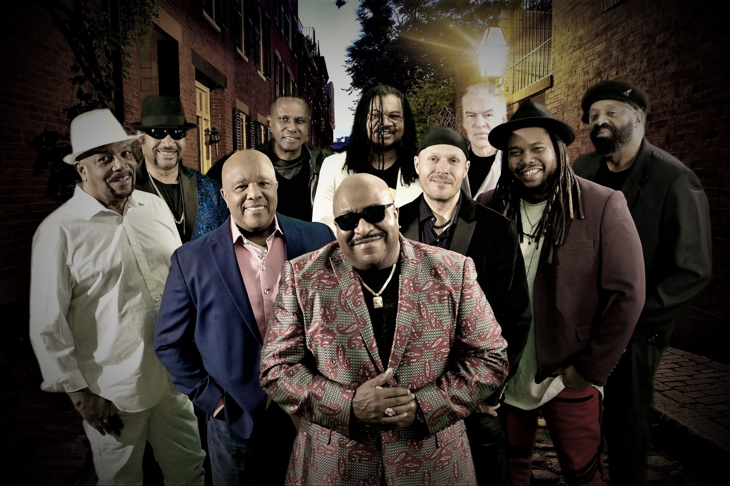

- December 2017 after 2 weeks “Top 50” 2017, Franklin Sinclair Mi-Soul Connoisseurs
- January 2018 #1 Sweet Rhythms Chart, Solar Radio, UK
- January 2018 #1 Hump Chart Teerex Radio Montreal, Canada
- February 2018 Top 10, Starpointe Radio, UK SOUL Chart
- February 2018, nominated Best RNB Album, Independent Music Awards (IMA), New York USA
- February 2018 #1 Your Love Wave.FM 94.7 HD2, Southern Ontario
- May 2018 Impact Award, CJRU, Paula LeTang/ Ryerson University
- June 2018 “Crack Of Dawn”, song Top 10 Wave.FM
- December 2018 OL Skool Remix, Top 10 Wave.FM
- December 2018, Top 40 Albums 2018 Teerex Radio
- December 2018, Winner Best International CD, La Music Critic
- January 1, 2019 #30 Top 100 New Year’s Day, UK Soul Chart

Thanks for all the support we’ve received from all our fans, radio, radio promotions, TV and Music critics, Distributors, Filmmakers and all those that have contributed to our modest success, so far.

Individual Acknowledgements to the following, in the beginning:
- Greg Gooding, Earl Jones, Michele Seaton-Gascon, Gloria Dunston, Dave Tollington
- Ontario Arts Council
- Carolyn McMaster, Chaos A Film Company
- Jeremy Darby, Cantebury Music Company
- Jim Zolis, Rose Room Recording
- Dave Darlington, Bass Hit Recording
- Paula LeTang-Loblack, CJRU
- Michael Amil, Teerex Radio
- Wave.FM, Mary Kirk, Stu Berketo and all the DJs
- Mark Daniels
- Quite Great Promotions, UK
- Pheromone Recording, Kim Cook
- Leib Kopman
- Parallel Vision Productions, Michelle Melles
- NRW Film Productions, Nicholette Williams

